### PCS AUTOMATION

Developed By

Name: K Naveenraj Reg. No: S200040300164

# NIIT

### PCS AUTOMATION

Batch Code : S210167

Start Date : 12.11.2020

End Date : 12.12.2020

Name of the Coordinator : LOPAMUDRA BERA

Name of the Developer : K NAVEENRAJ

Date of Submission : 12.12.2020

**NIIT**

###### CERTIFICATE

This is to certify that this report, titled **PCS AUTOMATION** embodies the original work done by **Mr.K Naveenraj**, in partial fullfillment of his course requirement at NIIT.

Coordinator : LOPAMUDRA BERA

### ACKNOWLEDGEMENT

I would like to express my special thanks of gratitude to my teacher **LOPAMUDRA BERA** as well as to the education institute **NIIT** who gave me the golden opportunity to do this wonderful project on the topic **PROFESSIONET CONSULTANCY SERVICES**, which also helped me in doing a lot of Research and i came to know about so many new things I am really thankful to them.  
Secondly i would also like to thank my parents and friends who helped me a lot in finalizing this project within the limited time frame.

### ABSTRACT

This project manages the entire process of allocating project to existing employees as per his/her skillset working in that company

Its also provides single window system to Employee,HR and Project Managers of a company to cater the skill specific requirements emerging in Projects.

### CONFIGURATION

Hardware:

* Laptop -i7
  + 16 Ram,2Tb Hard Disk

Operating System:Windows 10 x64

Software:JRE,Eclipse,MySql

### TABLE OF CONTENTS

Chapter 1- Introduction

1.0 Aim

1.1 Objectives

Chapter 2- Project Requirement Specification

2.0 Literature Research

2.1 Statement of Requirements

Chapter 3- Project Analysis

3.0 Project Plan

3.1 System Architecture

3.2 Business Process Model

3.3 Software Requirement Specification

3.4 High Level Use Case Diagrams

Chapter 4- Project Design

4.0 Low Level Use Case Diagrams

4.1 User Interface Design

4.2 Systems Input and Output Design

4.3 Database Structure

4.4 Sample Code

Challenges

Observations

References

Appendix

## AIM

To create an mapping application that operates via online recruiting website.

### OBJECTIVES

Following are the objectives to be achieved through Skill Mapping Application

* User registration
* Skill map
* Job Postings
* Profile Validation
* Recruitment

This objectives are to be automated which were previously done manually.

### LITERATURE RESEARCH

**Introduction**

To automate the existing recruitment procedures, which would help the HR Consultants to map the Job seekers with appropriate skills and offer workforce solutions to business needs.

**Background Information**

The recruitment and skill mapping were previously done manually by HR which would take weeks to sort the required user profile.

### STATEMENT OF REQUIREMENTS

PROJECT OBJECTIVES

|  |  |
| --- | --- |
| Title | PCS Automation |
| Subtitle | Employee Management System |
| Author(s) | K Naveenraj |
| Author’s E-mail | naveenrajkrishnan@gmail.com |
| Author’s Phone | 9942543332 |
| Description | Automated Consultancy Service |
| Version | 1.01 |

**About Your Company**

Professionet Consultancy Services(PCS) is a business consultancy which provides a wide range of business services to clients.

**Need for Process Automation**

* Adds consistency and quality to recruitment
* Improves the productivity of HR team
* Saves time by easing the workload
* Enables organizations to find the right talent

**Software Requirements**

* JRE
* ECLIPSE
* MYSQL

**Benefits**

* Improves the Recruitment Qualities.
* Pre-Screening of Candidates.

### PROJECT LIFE CYCLE MODEL

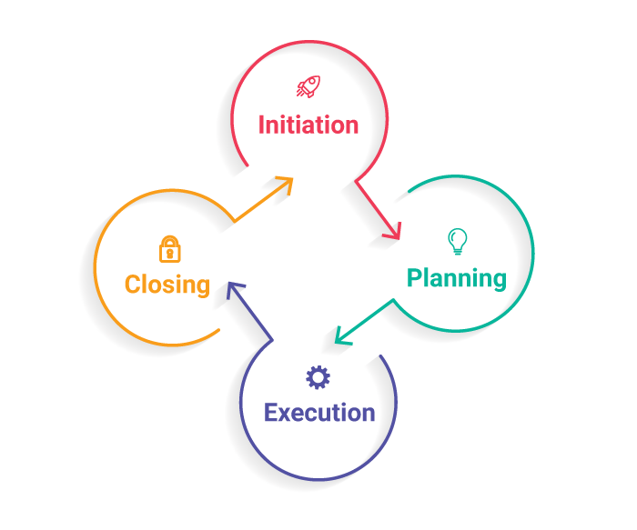

****The Initiation Phase:**** The initiation phase aims to define and authorize the project.

**Vision:Automate the Selection Process**

****The Planning Phase:**** The purpose of this phase is to lay down a detailed strategy of how the project has to be performed and how to make it a success.

Strategic Planning- overall approach to the project

Implementation Planning-ways to apply the decisions

****The Execution Phase:**** In this phase, the decisions and activities defined during the planning phase are implemented.

****The Termination Phase:**** This is the last phase of any project, and it marks the official closure of the project.

### SYSTEM ARCHITECTURE

1. Tier Architecture
2. A ****Presentation Layer**** that sends content to browsers in the form of HTML/JS/CSS. This might leverage frameworks like React, Angular, Ember, Aurora, etc.
3. An ****Application Layer**** that uses an application server and processes the business logic for the application. This might be written in C#, Java, C++, Python, Ruby, etc.
4. A ****Data Layer**** which is a database management system that provides access to application data. This could be MSSQL, MySQL, Oracle, or PostgreSQL, Mongo, etc.

**GUI Component**

(Login,Registration,HRA,EMP,PME)

**Presentation Layer**

Controller

**JRE**

**DATABASE**

(Tables-Emp,Job,

Skill,EmpSkill

EmpJob)

**JDBC Connectivity**

Gui Code

**Code**

**Application Layer**  **Data Access Layer**

### BUSINESS PROCESS MODEL

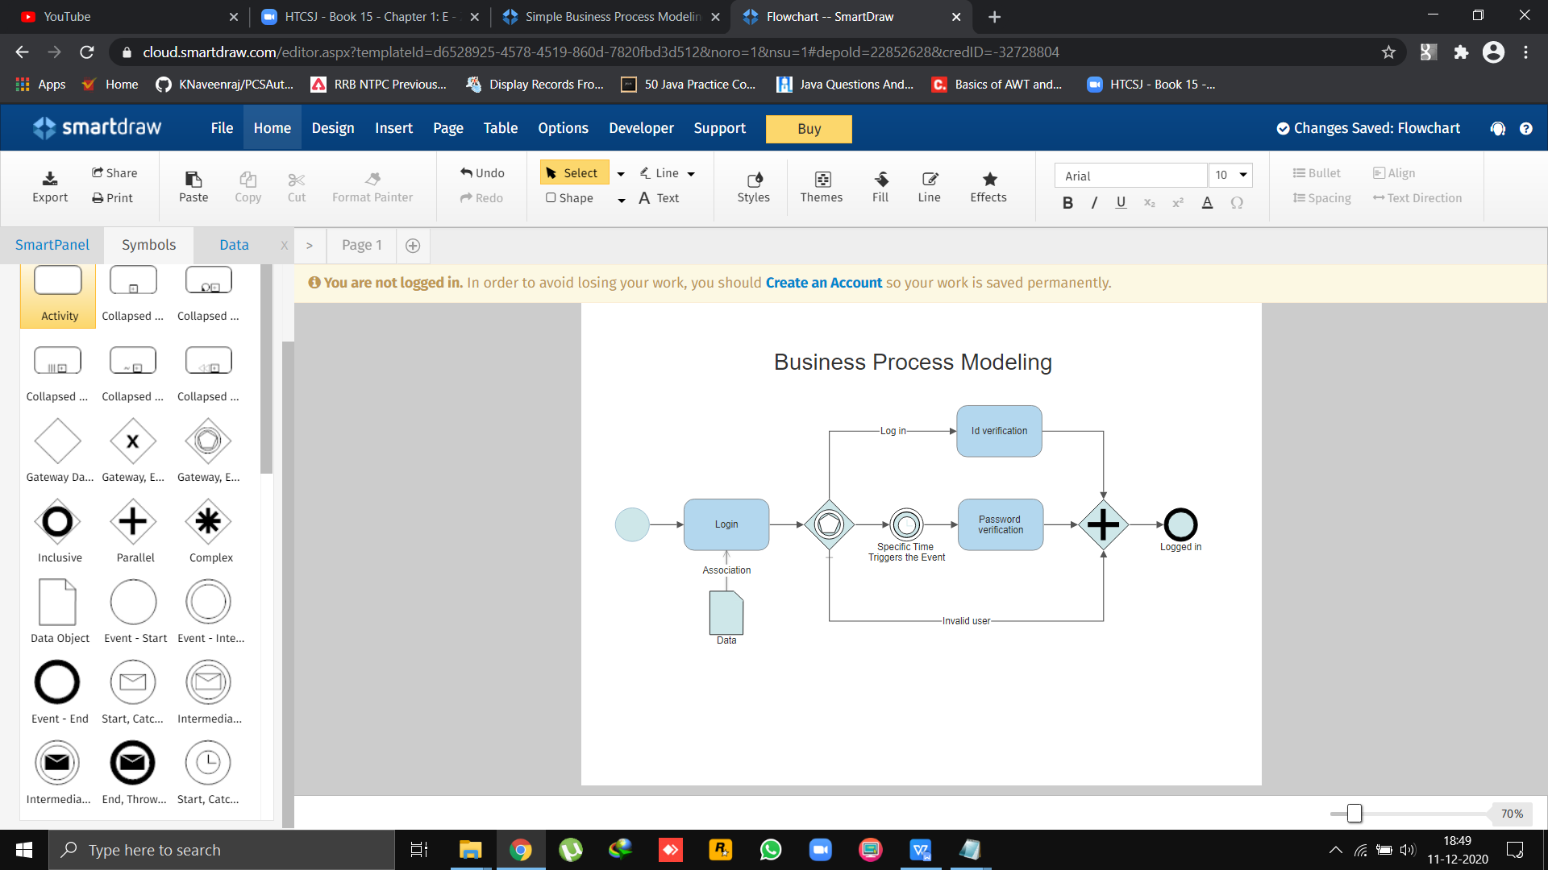

Business process modeling (or) process modeling, is the analytical representation or put simply an illustration of an organization’s business processes. Modeling processes is a critical component for effective [business process management](https://kissflow.com/bpm/business-process-management-overview/" \t "https://kissflow.com/bpm/business-process-modeling/_blank).

Benefits of business process modeling:

* Gives everyone a clear understanding of how the process works
* Provides consistency and controls the process
* Identifies and eliminates redundancies and inefficiencies
* Sets a clear starting and ending to the process

##### SOFTWARE REQUIREMNETS SPECIFICATION

Table of Contents

1. Introduction
   1. Purpose
   2. Scope
   3. Definitions,acronyms and abbreviations
   4. References
   5. Overview
2. General Description

2.1 Product perspective

2.2 Product functions

2.3 User characteristics

2.4 Constraints

2.5 Assumption and dependencies

1. Specific Requirements

3.1 Functional requirements

3.2 Non-functional requirements

3.3 External interface requirements

3.4 Performance requirements

3.5 Design constraints

3.6 Attributes

3.7 Other requirements

1. Appendices
2. Index

#### HIGH LEVEL USER CASE DIAGRAMS

HRA

**Role Check**

Login

EMP

Registration

PME

New user

Registration

PME

EMP

HRA

View skill-wise Employee list

View All available skills

Add Job

View all jobs

View skill wise jobs

View Employee list who applied for job

Deactivate Job

Logout

Activate employee

Deactivate employee

View all employees

View Selective employees

Add Skill

View all skills

Deactivate skill

Logout

View profile

Update Profile

Update Skill

Apply Job

Logout

DATABASE

JDBC

Operation

CODE

GUI CODE

CODE

#### LOW LEVEL USER CASE DIAGRAMS

EMP PME HRA

Application

Layer

User Interface Layer

Database

Layer

View profile

Apply job

**EMP**

Update profile

Logout

Update skill

View All available skills

View skill-wise Employee list

Add Job

View all jobs

**PME**

View Employee list who applied for job

View skill wise jobs

Deactivate Job

Logout

Deactivate Employee

Activate Employee

View selective employees

View all employees

**HRA**

Deactivate skills

Add skill

View all skills

Logout

### USER INTERFACE DESIGN

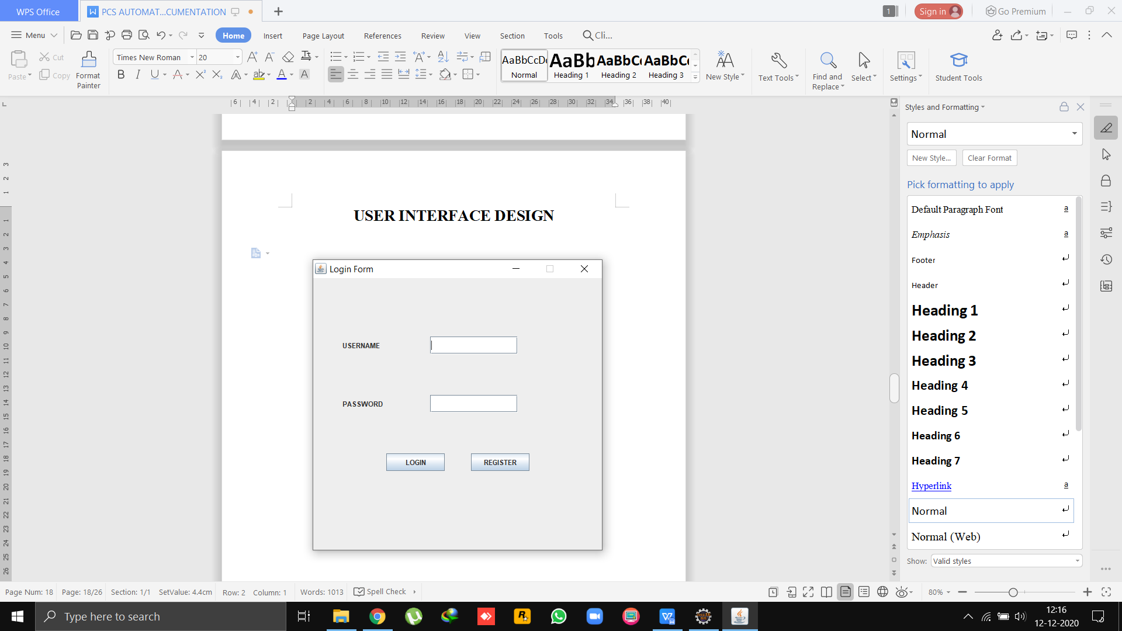

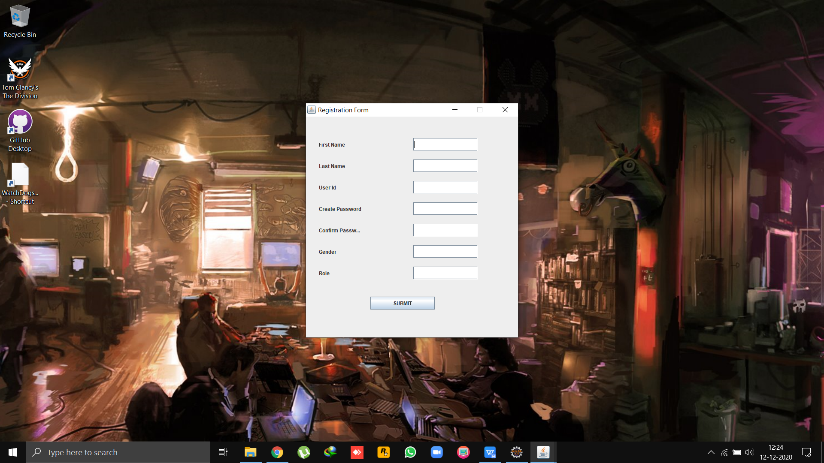

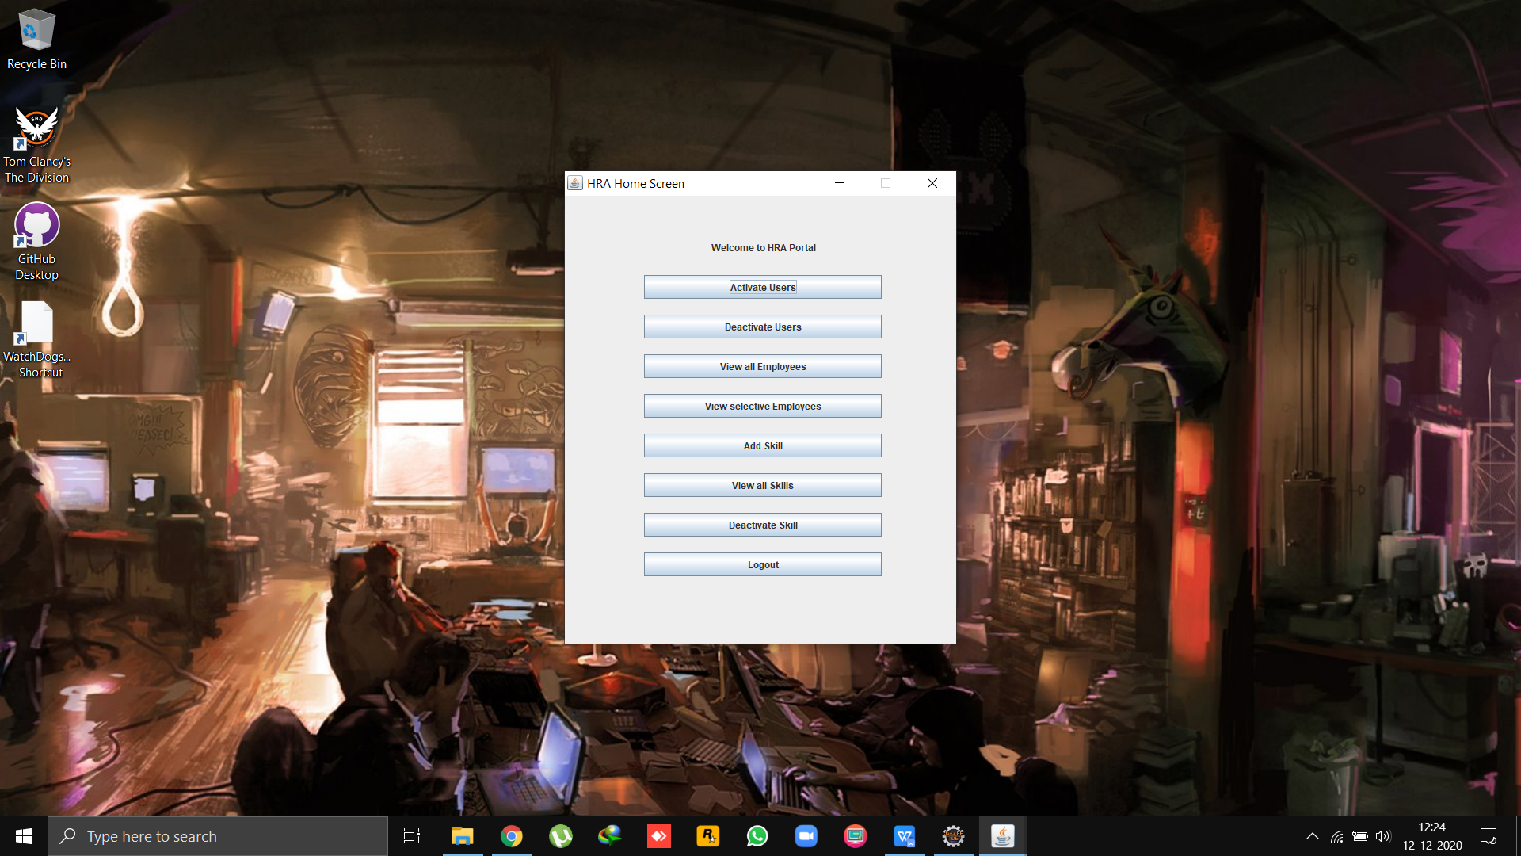

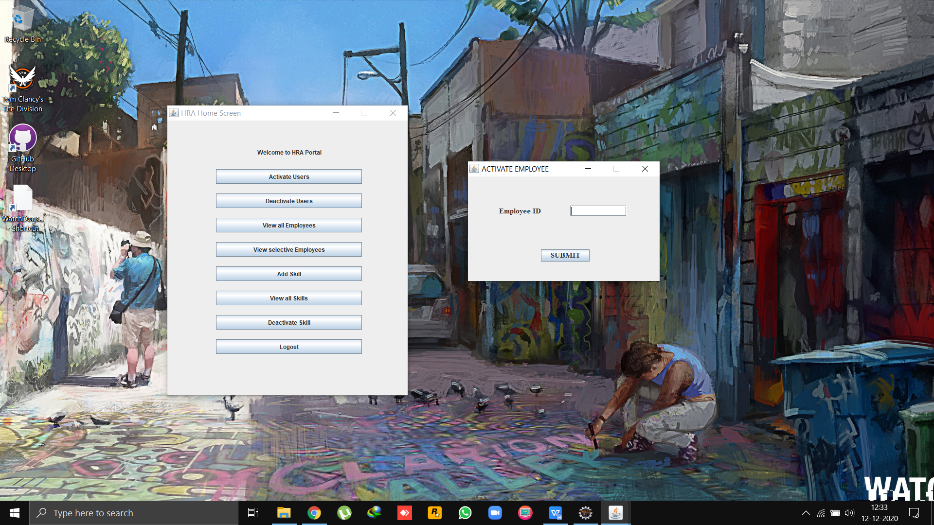

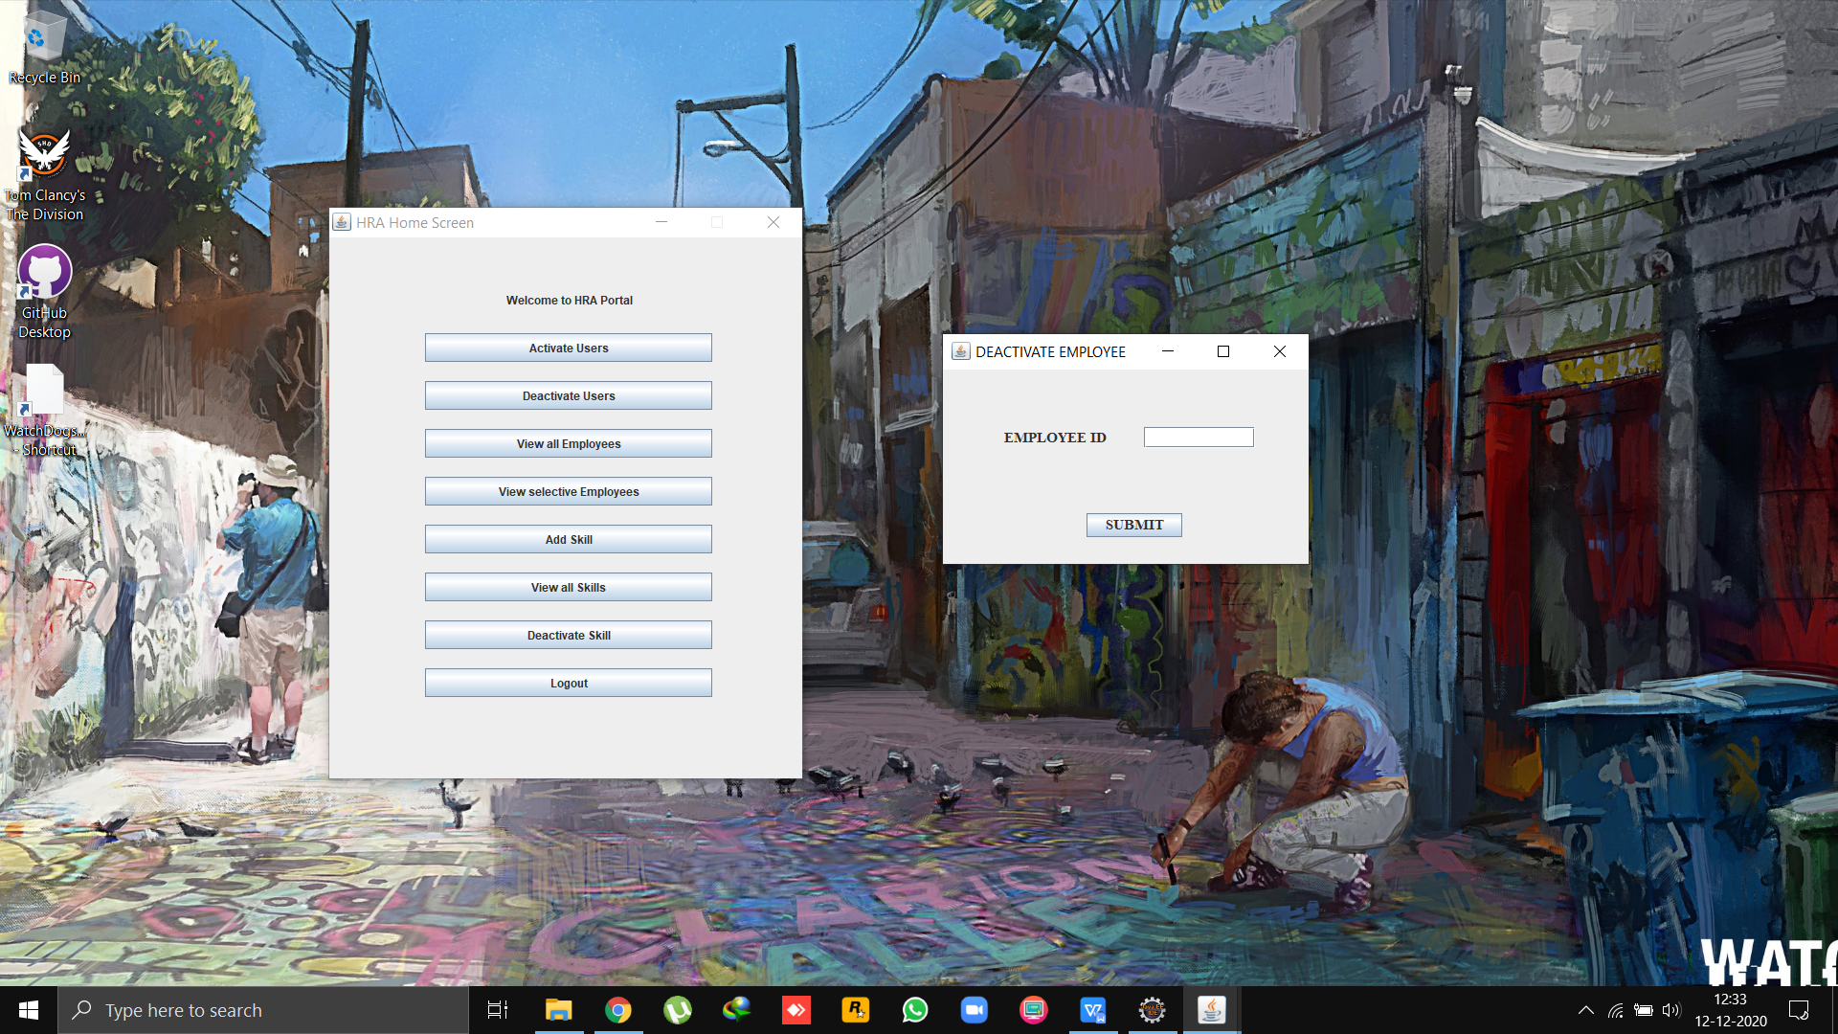

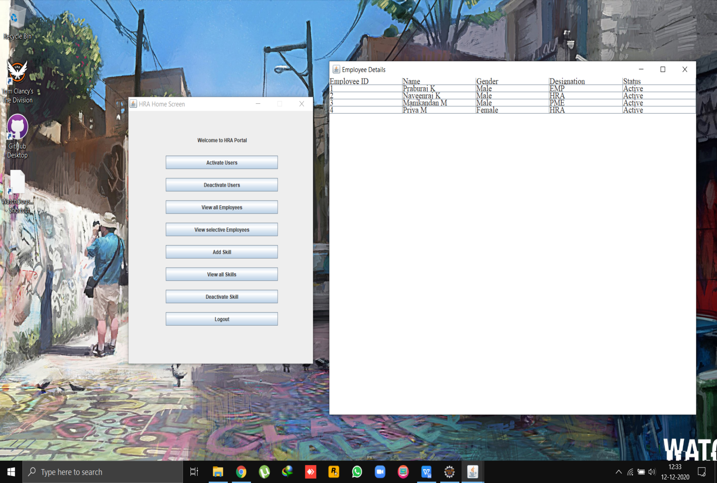

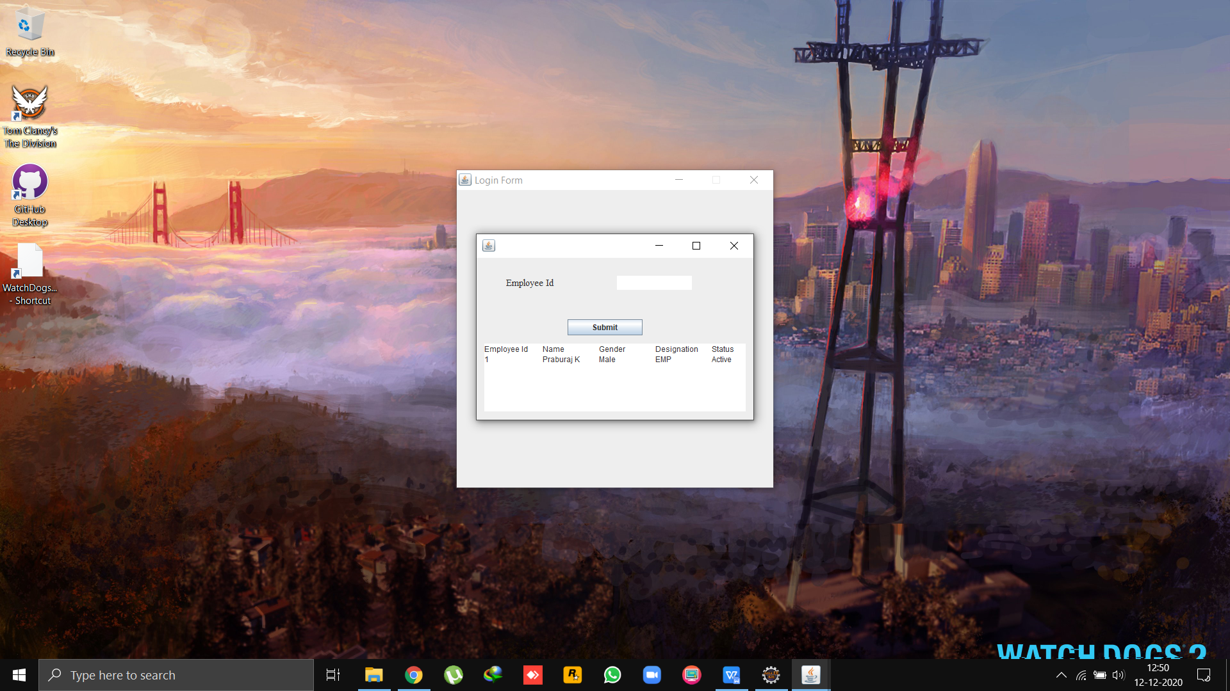

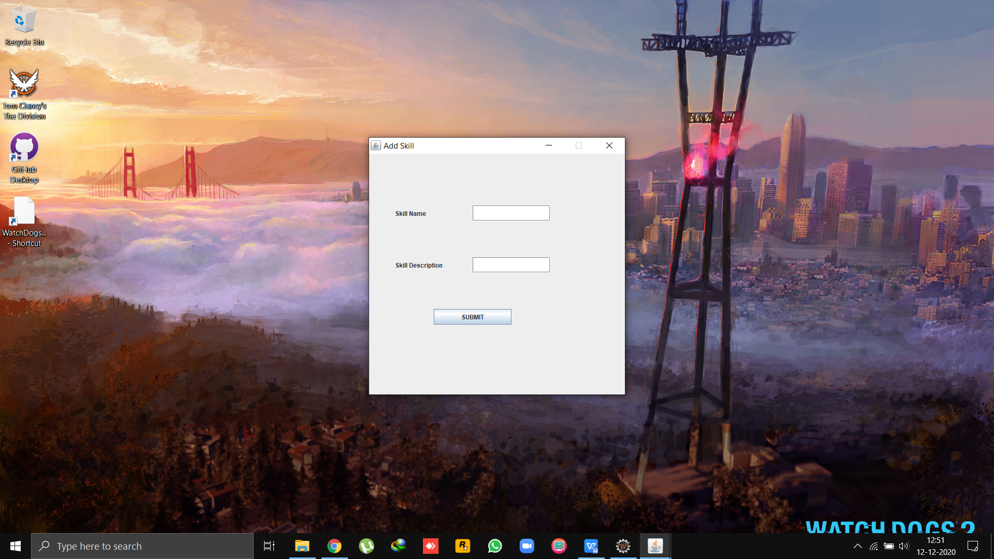

### 

### 

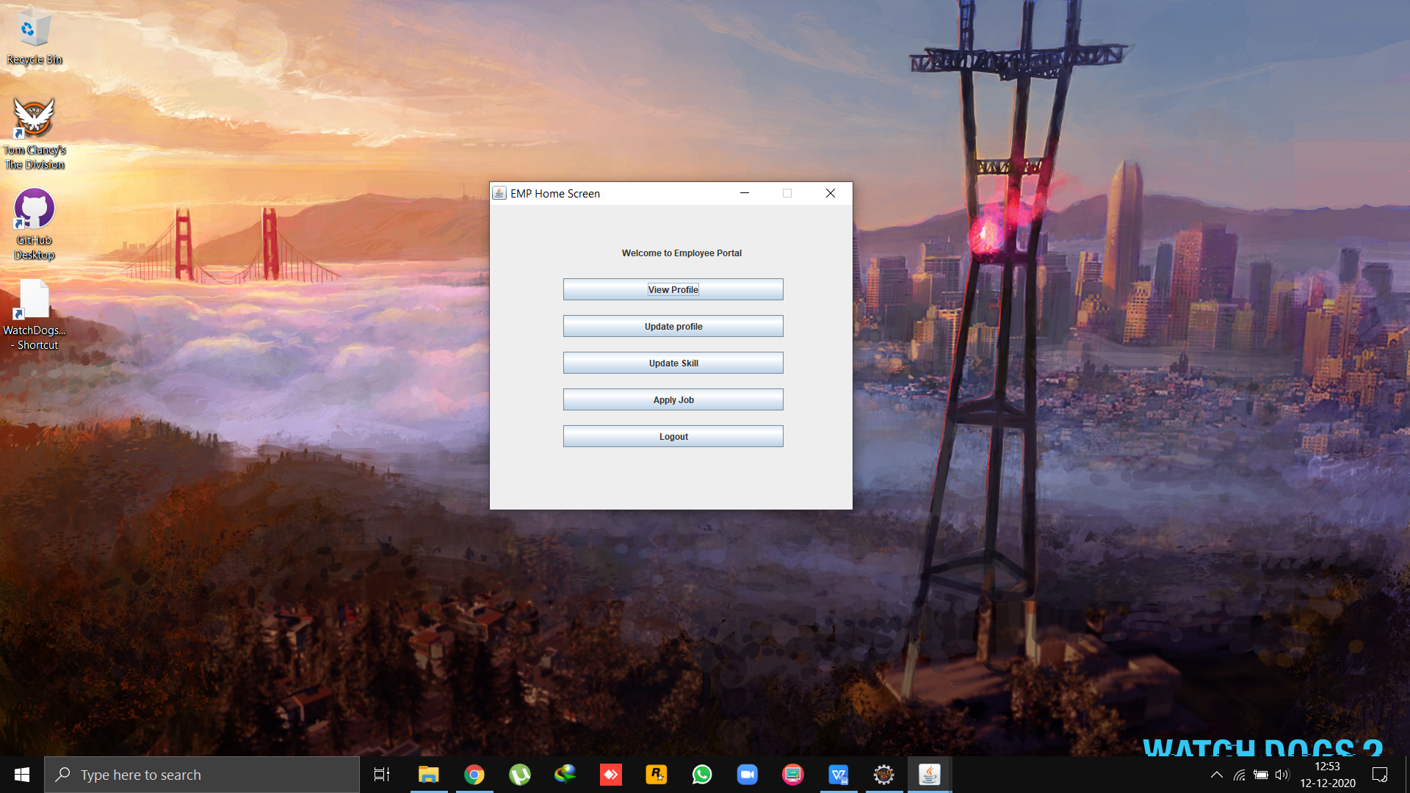

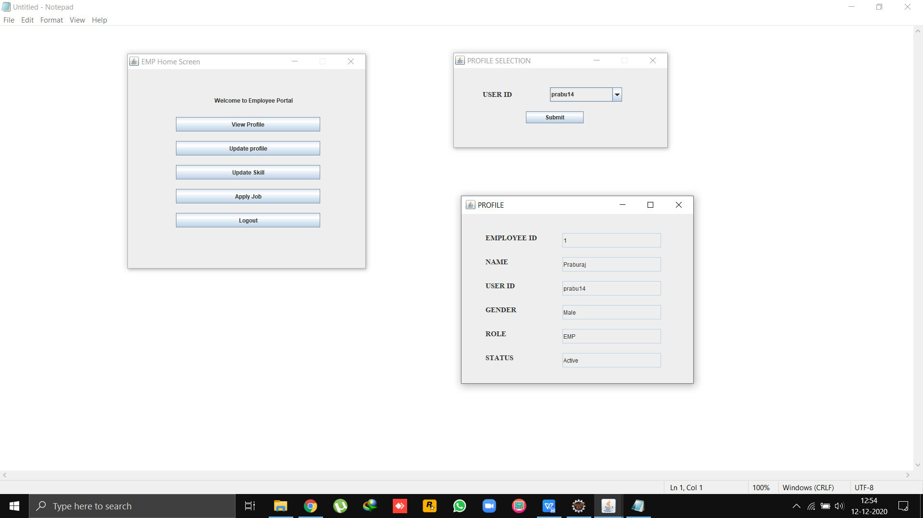

### 

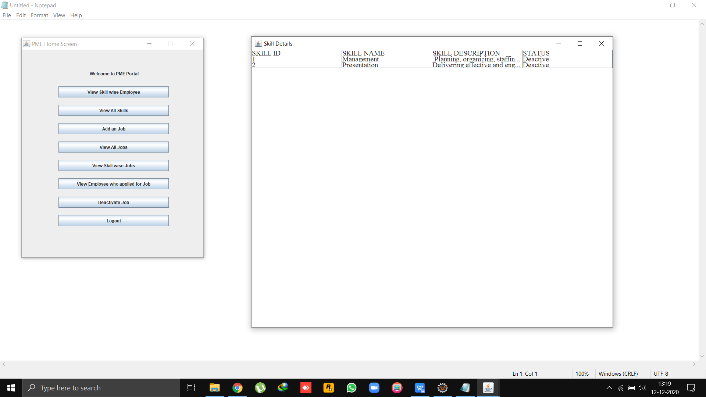

### 

### 

### 

### DATABASE STRUCTURE

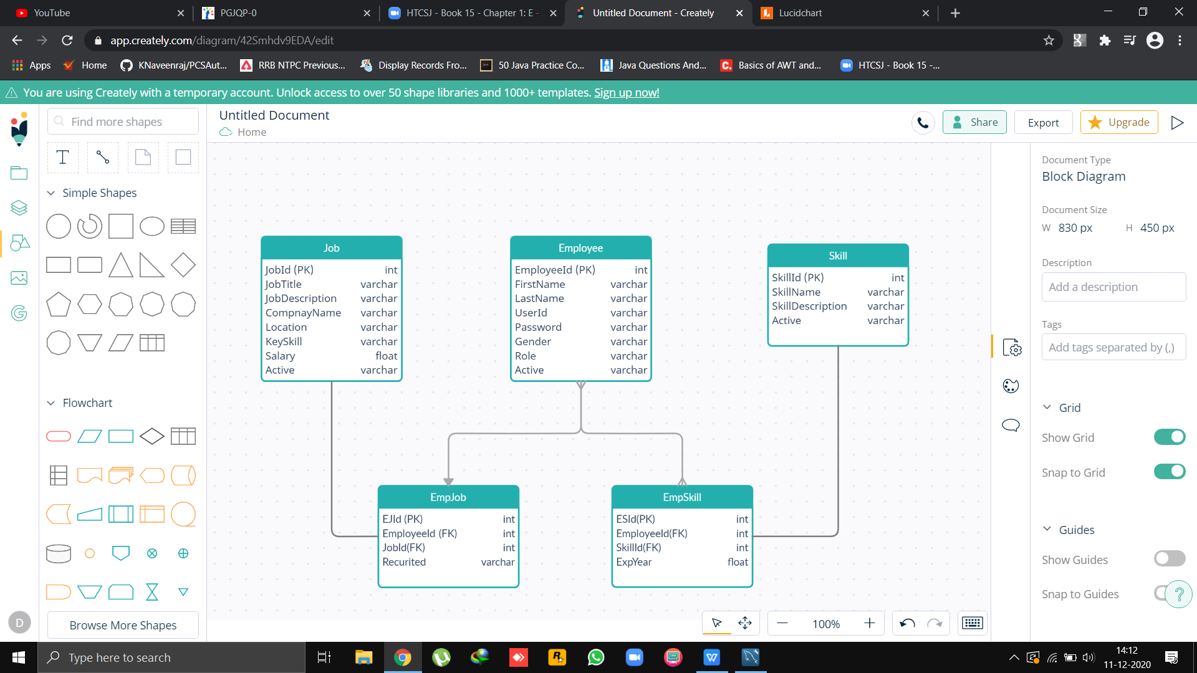

create database PCSDB;

use PCSDB;

create table Employee(

EmployeeId int auto_increment ,

FirstName varchar(30) not null,

LastName varchar(30)not null,

UserId varchar(30)not null,

Password varchar(20)not null,

Gender varchar(10)not null,

Role varchar(3)not null,

Active varchar(10)not null,

primary key(EmployeeId)

);

create table Skill(

SkillId int auto_increment ,

SkillName varchar(20)not null,

SkillDescription varchar(100)not null,

Active varchar(10)not null,

primary key(SkillId)

);

create table Job(

JobId int auto_increment ,

JobTitle varchar(20)not null,

JobDescription varchar(100)not null,

CompanyName varchar(50)not null,

Location varchar(20)not null,

KeySkill varchar(20)not null,

Salary float,

Active varchar(10)not null,

primary key (JobId)

);

create table EmpSkill(

ESId int auto_increment ,

EmployeeId int ,

SkillId int ,

ExpYear float,

primary key(ESID),

foreign key(EmployeeId) references Employee(EmployeeId),

foreign key(SkillId) references Skill(SkillId)

);

create table EmpJob(

EJId int auto_increment ,

EmployeeId int ,

JobId int ,

Recruited varchar(10)not null,

primary key(EJId),

foreign key(EmployeeId) references Employee(EmployeeId),

foreign key(JobId) references Job(JobId)

);

Select * from Employee;

Select * from Skill;

Select * from Job;

Select * from EmpSkill;

Select * from EmpJob;

### SAMPLE CODE

HRA

package view;

import java.awt.*;

import java.awt.event.ActionEvent;

import java.awt.event.ActionListener;

import java.sql.SQLException;

import javax.swing.*;

import controller.EmployeeController;

import controller.JobController;

import controller.SkillController;

import model.Employee;

import java.awt.Dialog;

public class HRAHome extends JFrame {

Container container;

JLabel lTitle;

JButton bSetActive,bSetDeactive,bViewAllEmp,bViewSelectiveEmp,bAddSkill,bViewAllSkill,bSetDeactiveSkill,bLogout;

JFrame f;

EmployeeController empController=null;

JobController jobController=null;

SkillController skillController=null;

public HRAHome() throws ClassNotFoundException, SQLException {

Employee emp=new Employee();

container=getContentPane();

empController=new EmployeeController();

jobController=new JobController();

skillController=new SkillController();

lTitle=new JLabel("Welcome to HRA Portal");

bSetActive=new JButton("Activate Users");

bSetActive.addActionListener(new ActionListener(){

@Override

public void actionPerformed(ActionEvent e) {

try {

new ActivateEmployee();

} catch (ClassNotFoundException e1) {

e1.printStackTrace();

} catch (SQLException e1) {

e1.printStackTrace();

}

}

});

bSetDeactive=new JButton("Deactivate Users");

bSetDeactive.addActionListener(new ActionListener(){

@Override

public void actionPerformed(ActionEvent e) {

try {

new DeactivateEmployee();

} catch (ClassNotFoundException e1) {

e1.printStackTrace();

} catch (SQLException e1) {

e1.printStackTrace();

}

}

});

bViewAllEmp=new JButton("View all Employees");

bViewAllEmp.addActionListener(new ActionListener(){

private ViewAllEmployees x;

@Override

public void actionPerformed(ActionEvent e) {

try {

//x = new ViewAllEmployees();

//x.showEmployeeData();

new EmployeeDetails();

} catch (ClassNotFoundException e1) {

e1.printStackTrace();

} catch (SQLException e1) {

e1.printStackTrace();

}

}

});

bViewSelectiveEmp=new JButton("View selective Employees");

bViewSelectiveEmp.addActionListener(new ActionListener(){

@Override

public void actionPerformed(ActionEvent e) {

try {

new ViewEmployeeById();

} catch (ClassNotFoundException e1) {

// TODO Auto-generated catch block

e1.printStackTrace();

} catch (SQLException e1) {

// TODO Auto-generated catch block

e1.printStackTrace();

}

}

});

bAddSkill=new JButton("Add Skill");

bAddSkill.addActionListener(new ActionListener(){

@Override

public void actionPerformed(ActionEvent e) {

try {

new AddSkillFrame();

} catch (ClassNotFoundException e1) {

// TODO Auto-generated catch block

e1.printStackTrace();

} catch (SQLException e1) {

// TODO Auto-generated catch block

e1.printStackTrace();

}

}

});

bViewAllSkill=new JButton("View all Skills");

bViewAllSkill.addActionListener(new ActionListener(){

@Override

public void actionPerformed(ActionEvent e) {

try {

new ViewAllSkills();

} catch (ClassNotFoundException e1) {

// TODO Auto-generated catch block

e1.printStackTrace();

} catch (SQLException e1) {

// TODO Auto-generated catch block

e1.printStackTrace();

}

}

});

bSetDeactiveSkill=new JButton("Deactivate Skill");

bSetDeactiveSkill.addActionListener(new ActionListener(){

@Override

public void actionPerformed(ActionEvent e) {

try {

new DeactivateSkill();

} catch (ClassNotFoundException e1) {

// TODO Auto-generated catch block

e1.printStackTrace();

} catch (SQLException e1) {

// TODO Auto-generated catch block

e1.printStackTrace();

}

}

});

bLogout=new JButton("Logout");

bLogout.addActionListener(new java.awt.event.ActionListener() {

public void actionPerformed(java.awt.event.ActionEvent evt) {

bLogoutActionPerformed(evt);

}

});

setLayoutManager();

setLocationAndSize();

addComponentsToContainer();

this.setTitle("HRA Home Screen");

this.setVisible(true);

this.setBounds(10,10,500,600);

//this.setDefaultCloseOperation(JFrame.EXIT_ON_CLOSE);

this.setResizable(false);

this.setLocationRelativeTo(null);

}

public void addComponentsToContainer() {

container.setLayout(null);

}

public void setLocationAndSize() {

lTitle.setBounds(185, 50, 300, 30);

bSetActive.setBounds(100,100,300,30);

bSetDeactive.setBounds(100,150,300,30);

bViewAllEmp.setBounds(100,200,300,30);

bViewSelectiveEmp.setBounds(100,250,300,30);

bAddSkill.setBounds(100,300,300,30);

bViewAllSkill.setBounds(100,350,300,30);

bSetDeactiveSkill.setBounds(100,400,300,30);

bLogout.setBounds(100,450,300,30);

}

public void setLayoutManager() {

container.add(lTitle);

container.add(bSetActive);

container.add(bSetDeactive);

container.add(bViewAllEmp);

container.add(bViewSelectiveEmp);

container.add(bAddSkill);

container.add(bViewAllSkill);

container.add(bSetDeactiveSkill);

container.add(bLogout);

}

private void bLogoutActionPerformed(ActionEvent evt) {

System.exit(0);

}

}

EMP

package view;

import java.awt.*;

import java.awt.event.ActionEvent;

import java.awt.event.ActionListener;

import javax.swing.*;

import controller.EmployeeController;

import model.Employee;

import java.sql.*;

public class EMPHome extends JFrame {

Container container=null;

JLabel lTitle;

JButton bViewprofile,bUpdateProfile,bUpdateSkill,bApplyJob,bLogout;

private EmployeeController empController;

public EMPHome(Employee emp) {

container=getContentPane();

try {

empController = new EmployeeController();

} catch (ClassNotFoundException e1) {

// TODO Auto-generated catch block

e1.printStackTrace();

} catch (SQLException e1) {

// TODO Auto-generated catch block

e1.printStackTrace();

}

lTitle=new JLabel("Welcome to Employee Portal");

bViewprofile=new JButton("View Profile");

bViewprofile.addActionListener(new ActionListener(){

@Override

public void actionPerformed(ActionEvent e) {

try {

new ViewProfile();

} catch (ClassNotFoundException e1) {

// TODO Auto-generated catch block

e1.printStackTrace();

} catch (SQLException e1) {

// TODO Auto-generated catch block

e1.printStackTrace();

}

}

});

bUpdateProfile=new JButton("Update profile");

bUpdateProfile.addActionListener(new ActionListener(){

@Override

public void actionPerformed(ActionEvent e) {

}

});

bUpdateSkill=new JButton("Update Skill");

bUpdateSkill.addActionListener(new ActionListener(){

@Override

public void actionPerformed(ActionEvent e) {

}

});

bApplyJob=new JButton("Apply Job");

bApplyJob.addActionListener(new ActionListener(){

@Override

public void actionPerformed(ActionEvent e) {

}

});

bLogout=new JButton("Logout");

bLogout.addActionListener(new java.awt.event.ActionListener() {

public void actionPerformed(java.awt.event.ActionEvent evt) {

bLogoutActionPerformed(evt);

}

});

setLayoutManager();

setLocationAndSize();

addComponentsToContainer();

this.setTitle("EMP Home Screen");

this.setVisible(true);

this.setBounds(10,10,500,450);

//this.setDefaultCloseOperation(JFrame.EXIT_ON_CLOSE);

this.setResizable(false);

this.setLocationRelativeTo(null);

}

public void setLayoutManager() {

container.setLayout(null);

}

public void setLocationAndSize() {

lTitle.setBounds(180,50,300,30);

bViewprofile.setBounds(100, 100, 300, 30);

bUpdateProfile.setBounds(100, 150, 300, 30);

bUpdateSkill.setBounds(100, 200, 300, 30);

bApplyJob.setBounds(100, 250, 300, 30);

bLogout.setBounds(100, 300, 300, 30);

}

public void addComponentsToContainer() {

container.add(lTitle);

container.add(bViewprofile);

container.add(bUpdateProfile);

container.add(bUpdateSkill);

container.add(bApplyJob);

container.add(bLogout);

}

private void bLogoutActionPerformed(ActionEvent evt) {

System.exit(0);

}

}

PME

package view;

import java.awt.*;

import java.awt.event.ActionEvent;

import java.awt.event.ActionListener;

import java.sql.SQLException;

import javax.swing.*;

public class PMEHome extends JFrame{

Container container=null;

JLabel lTitle;

JButton bViewSkEmp,bViewAllSkill,bAddJob,bViewAllJobs,bViewSkJobs,bViewEmpApJob,bSetDeactiveJob,bLogout;

public PMEHome() {

container=getContentPane();

lTitle=new JLabel("Welcome to PME Portal");

bViewSkEmp=new JButton("View Skill wise Employee");

bViewSkEmp.addActionListener(new ActionListener(){

@Override

public void actionPerformed(ActionEvent e) {

}

});

bViewAllSkill=new JButton("View All Skills");

bViewAllSkill.addActionListener(new ActionListener(){

@Override

public void actionPerformed(ActionEvent e) {

try {

new ViewAllSkills();

} catch (ClassNotFoundException e1) {

// TODO Auto-generated catch block

e1.printStackTrace();

} catch (SQLException e1) {

// TODO Auto-generated catch block

e1.printStackTrace();

}

}

});

bAddJob=new JButton("Add an Job");

bAddJob.addActionListener(new ActionListener(){

@Override

public void actionPerformed(ActionEvent e) {

try {

new AddJobFrame();

} catch (ClassNotFoundException e1) {

// TODO Auto-generated catch block

e1.printStackTrace();

} catch (SQLException e1) {

// TODO Auto-generated catch block

e1.printStackTrace();

}

}

});

bViewAllJobs=new JButton("View All Jobs");

bViewAllJobs.addActionListener(new ActionListener(){

@Override

public void actionPerformed(ActionEvent e) {

try {

new ViewAllJobs();

} catch (ClassNotFoundException e1) {

// TODO Auto-generated catch block

e1.printStackTrace();

} catch (SQLException e1) {

// TODO Auto-generated catch block

e1.printStackTrace();

}

}

});

bViewSkJobs=new JButton("View Skill wise Jobs");

bViewSkJobs.addActionListener(new ActionListener(){

@Override

public void actionPerformed(ActionEvent e) {

}

});

bViewEmpApJob=new JButton("View Employee who applied for Job");

bViewEmpApJob.addActionListener(new ActionListener(){

@Override

public void actionPerformed(ActionEvent e) {

}

});

bSetDeactiveJob=new JButton("Deactivate Job");

bSetDeactiveJob.addActionListener(new ActionListener(){

@Override

public void actionPerformed(ActionEvent e) {

try {

new DeactivateJob();

} catch (ClassNotFoundException e1) {

e1.printStackTrace();

} catch (SQLException e1) {

e1.printStackTrace();

}

}

});

bLogout=new JButton("Logout");

bLogout.addActionListener(new java.awt.event.ActionListener() {

public void actionPerformed(java.awt.event.ActionEvent evt) {

bLogoutActionPerformed(evt);

}

});

setLayoutManager();

setLocationAndSize();

addComponentsToContainer();

this.setTitle("PME Home Screen");

this.setVisible(true);

this.setBounds(10,10,500,600);

//this.setDefaultCloseOperation(JFrame.EXIT_ON_CLOSE);

this.setResizable(false);

}

private void addComponentsToContainer() {

container.setLayout(null);

}

private void setLocationAndSize() {

lTitle.setBounds(185, 50, 300, 30);

bViewSkEmp.setBounds(100,100,300,30);

bViewAllSkill.setBounds(100,150,300,30);

bAddJob.setBounds(100,200,300,30);

bViewAllJobs.setBounds(100,250,300,30);

bViewSkJobs.setBounds(100,300,300,30);

bViewEmpApJob.setBounds(100,350,300,30);

bSetDeactiveJob.setBounds(100,400,300,30);

bLogout.setBounds(100,450,300,30);

}

private void setLayoutManager() {

container.add(lTitle);

container.add(bViewSkEmp);

container.add(bViewAllSkill);

container.add(bAddJob);

container.add(bViewAllJobs);

container.add(bViewSkJobs);

container.add(bViewEmpApJob);

container.add(bSetDeactiveJob);

container.add(bLogout);

}

private void bLogoutActionPerformed(ActionEvent evt) {

System.exit(0);

}

}